GUIDANCE NOTE ON MONITORING, EVALUATION AND LEARNING PLANS FOR INTERVENTIONS
The Quality Assurance Board expects that all interventions have a plan for Monitoring, evaluation and learning (a MEL plan). This guidance note was prepared by EVA-11 to supplement the guidelines by the Ministry for Foreign Affairs of Finland (MFA) Quality Assurance Board, in order to give further guidance on key elements generally covered by MEL plans.
Monitoring, evaluation and learning are important elements in the management for results of Finland’s development policy. The format of MEL plans varies according to partner organizations. Furthermore, there may be specific requirements set by the various MFA funding instruments and their rules and regulations. MFA expects that MEL is a planned aspect in each project or programme it supports.
This guidance note consists of two parts:
- Part A was developed for interventions that are using an integrated Monitoring, Evaluation and Learning (MEL) Plan

- Part B was developed for interventions that have a separate Evaluation Plan developed for their intervention.
Use the part relevant to your intervention.
Monitoring refers to “a continuing function that uses systematic collection of data on specified indicators to provide management and the main stakeholders of an ongoing development intervention with indications of the extent of progress and achievement of objectives and progress in the use of allocated funds”. (OECD DAC 2010).
Evaluation refers to a systematic and impartial assessment of an intervention to determine its relevance, coherence, efficiency, effectiveness, impact and sustainability especially to support decision-making and strengthen accountability and learning. Evaluations can be summative (backward looking, supporting accountability) or formative (forward-looking, supporting learning) or both. In some cases, developmental evaluation methodologies can be applied for developing new and innovative ways of doing things. Finland's development cooperation evaluations are regulated by the MFA’s internal norm 1/2015 on Development Evaluation and guided by MFA Evaluation Manual. The expectation is that each project is evaluated at least once during the project cycle.

A. GUIDANCE NOTE ON MEL PLANS
This internal guidance note is developed for the purpose of further specifying what minimum contents are expected in the MEL plans of interventions funded by the Ministry for Foreign Affairs (MFA), especially in relation to evaluations and other evaluative activities.
The purpose of an MEL plan at an intervention level is to support the identification of needed information for the management and leadership of the given project or programme in order to assess whether and to what extent the implementation is on track to meet its objectives and targets. The plan covers utilization of existing information, plans to create new information as well as the moments to identify possible new needs of information. It covers the entire project cycle as a continuous process in order to collect information in a systematic way on the performance of the intervention. This information, then, is used for evidence-based decisions and/or adaptations in order to better meet the objectives.
When drafting the MEL plan, you should consider the overall information and evidence needs for your intervention. The forms in which you may gain information may be, for example, annual reports, evaluations, studies/analyses, reviews, monitoring visits, annual review meetings, stakeholder consultations, and audits.
Consider:
- What do we need to know and why? (purpose and form)
- From where and how can we get the information? (partner, jointly, ourselves)
- When do we need to know this? (timing; which ones are continuous e.g. on a quarterly or annual basis or single events/activities – when?)
- How do we use the information/what for? (purpose, form, timing)
- How do we communicate and share information including results and lessons learnt (learning)
MEL plans should support the results based management of the intervention and thus be aligned with what is described in the programme or project document for the intervention – particularly in the monitoring and evaluation chapter(s) where the procedures related to the above questions are given, and the roles, processes, activities, systems and tools are described in writing (approx. 0,5-2 pages). Similarly, they should be aligned with the results framework and budget documents for the intervention.
MEL plans typically entail the following general aspects:
- What do we need to know and why? Consider the different types of information needs at different result levels and result areas and the different timings (annually and throughout the project or programme cycle). Ensure adequate coverage of the intervention and its results areas with the various monitoring, evaluation and learning activities.
- Type of Monitoring, Evaluation and Learning activity: Identify the different types of MEL activities.
- From where and how to get the information? Identify the sources of verification.
- How will the evidence be used? Who will use it? Indicate how and when the information will be used, e.g. for planning phase II of the intervention, policy dialogue at a high level event, final reporting to stakeholders, developing a strategy or a guideline on a specific theme etc.
- When? Specify the timing for the MEL activity.
- Who carries out? Specify who will carry out the MEL activity and who is responsible. These may be e.g. project managers or coordinators. Specify, separately, the designated M&E-related staff positions or designated duties in order to demonstrate adequate technical expertise in the organization.
- Final Report date & archive: set the end date and ensure documentation, communication and archiving requirements are met, such as publishing evaluations on the MFA website, saving the evaluation and annual reports, and reporting in AHA-KYT system.
- Anticipated cost: Ensure that all MEL activities are budgeted for, and that adequate resources are available (financial, human, time, venues, travel means, etc.)
The format is free and varies according to the funding instrument or the partner organization. Annex 1 to this guidance note provides one sample template, readily modifiable.

ANNEX 1 – SAMPLE: MONITORING, EVALUATION AND LEARNING PLAN TEMPLATE

Impact / Results Areas covered | What do we need to know and why? | Type of Monitoring, Evaluation and Learning activity | From where and how to get the information?  (sources of verification) | How and by whom will the evidence be used? | When?  Timing  (month/year) | Who carries out? | Final Report date & archive | Anticipated cost
Total costs of Monitoring, evaluation and learning activities
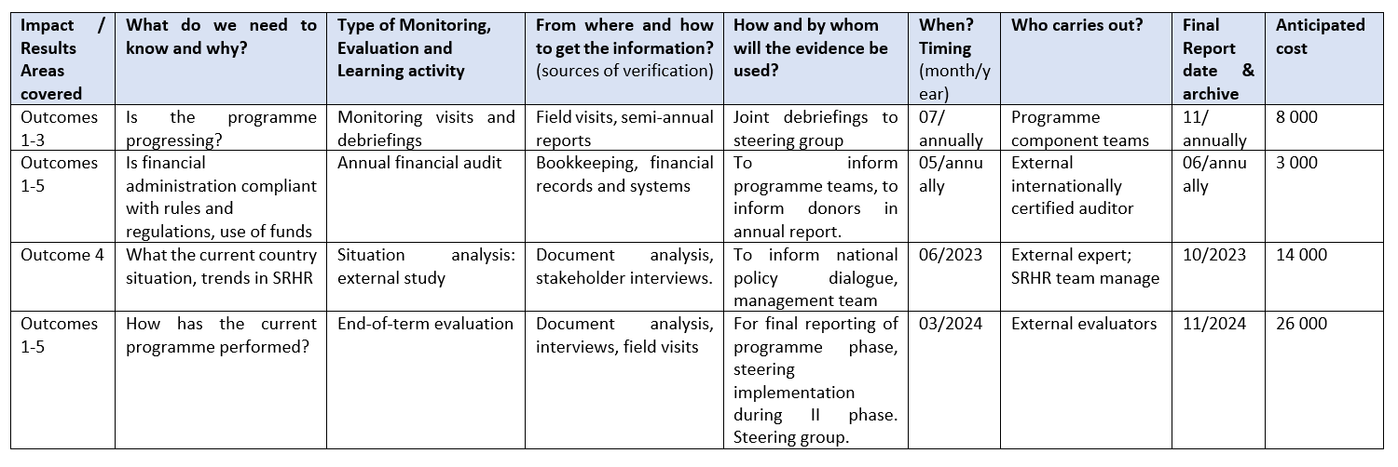
Fictional example:

B. GUIDANCE NOTE ON EVALUATION PLANS
This internal guidance note is developed for the purpose of further specifying what minimum contents are expected in the evaluation plans of interventions funded by the Ministry for Foreign Affairs (MFA).
When drafting the evaluation plan, you should consider the overall information and evidence needs for your intervention, and which of them would be covered or verified by external evaluators.

Consider:
- What do we need to know and why? (purpose and form)
- From where and how can we get the information? (partner, jointly, ourselves)
- When do we need to know this? (timing)
- How do we use the information/what for? (purpose, form, timing)
- How do we communicate and share information including results and lessons learnt (learning)
Evaluation plan should be aligned with what is described in the programme or project document for the intervention – particularly in the monitoring and evaluation chapter(s) where the procedures related to the above questions are given, and the roles, processes, activities, systems and tools are described in writing (approx. 0,5-2 pages). Similarly, it should be aligned with the results framework and budget documents.
Evaluation plans typically entail the following general aspects:
- What evaluations and other evaluative assessments (e.g. mid-term review/evaluation) will be conducted? (Consider what do you need to know; what types are needed at what stage; where do you need an evaluation and where another type of assessment is in order; what will be the quality of information produced by each; what will you conduct alone vs. joint evaluations)
- Will the intervention be evaluated as a whole or in part? What outcome areas / components / themes / geographical regions of the intervention will be covered by each? (Consider information needs and coverage of the intervention. Consider a combined evaluation with another project)
- When will the evaluation(s) be conducted? (Consider timeliness, sequencing, synergies of producing and accumulating information)
- What information needs will the evaluation(s) feed into? What will be the intended use of the reports and by whom? (Consider what process are ongoing related to strategic and programme planning, learning, accountability, advocacy and policy dialogue).
- Who are the key stakeholders in conducting the evaluation (Consider who needs to be informed, consulted and/or involved etc.)
- How will the evaluation and its results be communicated? (Consider how the key stakeholders will be engaged during the whole evaluation process. This enhances learning but also recognition of the evaluation results. Remember to publish the evaluation report on the MFA web site as well as store in and report through AHA-KYT.)
- What is the estimated cost of the evaluation, review or assessment? Ensure the evaluation is budgeted for.
The format is free and varies according to the funding instrument or the partner organization. Annex 2 to this guidance note provides one sample template readily modifiable.

ANNEX 2 – SAMPLE: EVALUATION PLAN TEMPLATE
Impact/Results areas/components/themes/regions covered | Start date (month/year) | Evaluation title | Intended use of findings and by whom | Key partners or stakeholders | Communication | Anticipated cost
Total costs of evaluations and other evaluative assessments
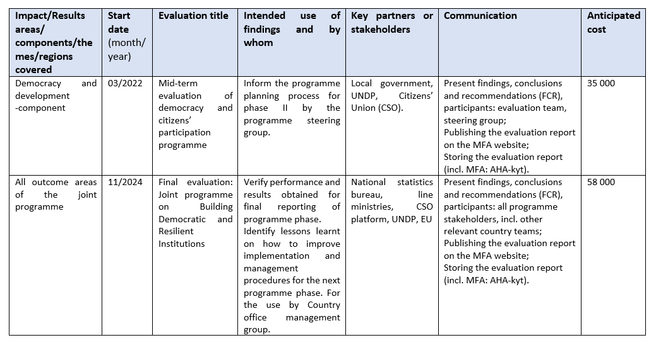
Fictional example:

All MFA staff are requested to check the latest guidelines and requirements for the relevant funding instrument at KETTU: https://kampus.vnv.fi/yhteiset-toiminnot/Sivut/Kehitysyhteisty%C3%B6n-tukipaketti.aspx.
https://www.eoppiva.fi/kurssit/evaluation-manual-2/#/.

