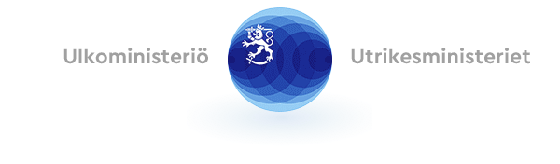
When filled in the form is to be kept secret in accordance with section 24 subsection 1 subparagraph 20 of the Act on the Openness of Government Activities (621/1999)

SANCTIONS AND SANCTION CIRCUMVENTION
Sanctions Regulations are directly applicable law in the European Union Member States. The EU’s sectoral sanctions and individual sanctions should be implemented in parallel. If an export operation is not prohibited by the sectoral sanctions, the exporter should still implement individual sanctions and make sure that the exported goods or technologies do not benefit the sanctioned parties or entities under their ownership or control. Sanction circumvention is prohibited by the Regulations and circumvention is punishable criminal activity according to Member States legislation. The exporter shall therefore also take into account the risks associated with sanction circumvention. The exporter shall provide information on the grounds for its application and also in other respects contribute to the proper review of the matter it has instigated. This form contains questions put to companies by the Export Control Unit of the Department of Trade at the Ministry for Foreign Affairs in the context of export control matters. This form is not the sole means of review, however.
As the national competent authority responsible for the export control of dual-use items, the Export Control Unit at the Ministry for Foreign Affairs has the basis under Article 6(1)(c) of the General Data Protection Regulation of the EU to process personal data in its consideration of authorisations. The processing is necessary for compliance with the obligations under the Act on the Control of Exports of Dual-Use Goods. When filled in, the form may contain personal data. This shall be processed in accordance with data protection legislation. Information relating to the processing of personal data and data protection at the Ministry for Foreign Affairs is available at: https://um.fi/dataprotection

- Have you reviewed the document Detecting and Preventing Sanctions Evasion and Circumvention in Trade – Practical Guidance for Economic Operators available on the Ministry for Foreign Affairs website? Link: https://valtioneuvosto.fi/-/ohjeita-yrityksille-pakotteiden-kiertamisen-tunnistamiseksi-ja-ehkaisemiseksi?languageId=en_US
- Is the country of location of the consignee or end-user, your product/service or the consignee/end-user itself subject to sanctions?

- Is the consignee/end-user owned or controlled by a sanctioned party? Is it a part of a chain where it is complicated to trace ownership to a beneficial owner? Does the business partner have, or has it had, links with politically exposed persons or sanctioned persons or entities?

- Does the export involve a risk of sanction circumvention?

- Does your business contract include a clause on sanction circumvention and liability?

- How will the relevant goods/technologies be transported? What routes are to be taken?

- Is this a new business partner for you in the third country?

- Is the consignee/end-user only recently incorporated or has it merged with a sanctioned entity or an entity linked with a sanctioned entity or individual?

- Does the consignee/end-user have the same address as several other, different companies?

- Is the consignee a company focusing on the transport of goods or a brokerage agency/intermediary?

- Are you familiar with the business of the consignee/end-user and with any changes in their business profile? Has the quantity of items ordered by the customer increased recently in a way that it is not consistent with the known/ordinary end-user needs/business?

- Is the business line of the consignee/end-user consistent with the goods and technologies ordered/delivered? How plausible is the end-use of the goods or technologies exported, taking into account the company’s business profile and undertakings?

- Does the consignee/end-user trade in goods/technologies to which export/import restrictions apply?

- Is the final end-use of the goods/technologies exported to third countries a logistics warehouse?

- Other comments on sanctions and sanction circumvention

